**Lab 03**

**For all problems, write the pseudo-code, draw the flowchart and the structure chart.**

1. Write the pseudo-code and draw the flowchart of a program that prints the following sequences of values in loops:

a) 24, 18, 12, 6, 0

b) -10, -5, 0, 5, 10, 15

c) 18, 27, 36, 45, 54

2 Write the pseudo-code and draw the flowchart of a program that calculates and prints the sum of the even integers from 10 to 60.

3. Write the pseudo-code and draw the flowchart of a program that calculates and prints the product of the odd integers from 3 to 13.

4. Write the pseudo-code and draw the flowchart of a program that will calculate the value of y if the expression of y is as follows (n is the input):

5. Write the pseudo-code and draw the flowchart of a program that will calculate the value of y if the expression of y is as follows (n is the input):



6. Write the pseudo-code and draw the flowchart of a program that compute and display a person’s weekly salary as determined by the following conditions:

If the hours worked are less than or equal to 40, the person receives Tk200.00 per hour, else the person receives Tk8000.00 plus Tk300.00 for each hour worked over 40 hours.

(Hint: The program should request the hours worked as input and should display the salary as output).

7. A student will be placed on probation if his CGPA falls below 2.0 in an exam. Write the pseudo-code and draw the flowchart of a program that reads a student’s CGPA from the standard input and prints on the standard output whether he is on probation or not.

8. Write the pseudo-code and draw the flowchart of a program that reads marks of ten courses and prints the maximum, minimum and average of those ten marks.

9. Suppose the following expressions are used to calculate the values of L for different values of S:

L = 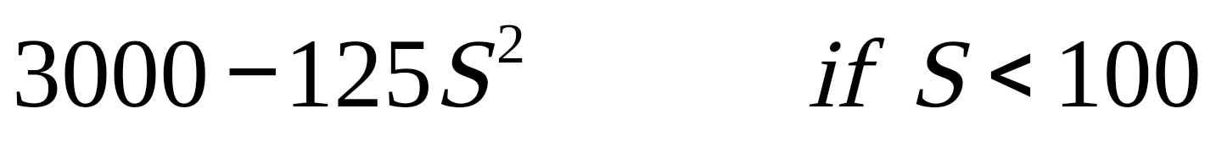

L = 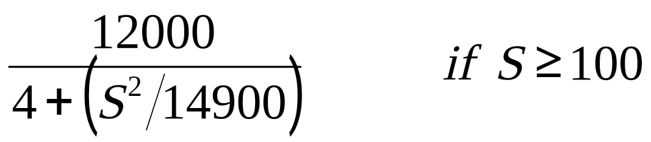

Write the pseudo-code and draw the flowchart of a program that reads a value of S and then calculates the value of L.

10. Write the pseudo-code and draw the flowchart of a program that reads the value of *n* and calculates the value of y if the expression of y is as follows:



11. Write the pseudo-code and draw the flowchart of a program that reads the values for the three sides x, *y*, and z of a triangle, and then calculates its area. The area is calculated as follows: 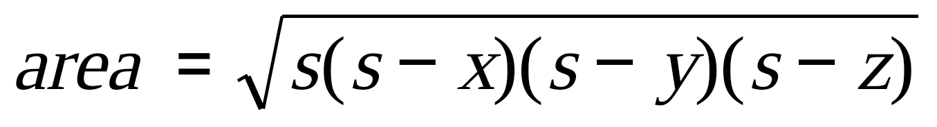

where s is 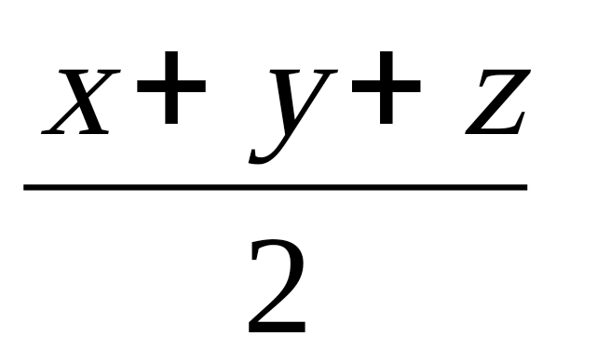 .

12. Draw the flowchart and write the pseudo-code for the following:

1. Ask the user to enter his/her name.
2. Ask the user to enter a Number
3. Display the name of the user, number of times specified in the second step.

Example: If the user enters “John” and 6, your program should print the name John six times.

13. Draw the flowchart and write the pseudo-code for the following:

Take seven numbers input from the user and find the maximum and the average.

14. a) Do problem 13 to find the minimum and the average of those seven numbers.

b) Find the maximum and the average of the odd numbers entered by the user. [If the user enters even numbers ignore them]

15. Draw the flowchart and write the pseudo-code for the following:

* Ask the user to enter a Number
* Display the summation of multiples of 7 up to that number.

Example: If the user enters 50, your program should print 196. (because: 7 + 14 + 21 + 28 + 35 + 42 + 49 = 196).

16. Write a complete pseudo-code and the flowchart of a program, which adds all the multiples of 7 and 9 up to 300.

17. Write a Flowchart and Pseudocode for the following:

Ask the user to enter ten numbers then display ONLY the total and the average of the odd numbers among those ten numbers.

[Hint: Example Input: 1 2 3 4 5 6 7 8 9 10 and Example Output: Total is 25 and Average is 5 (i.e., Total is 25 = (1+3+5+7+9) and Average is 25/5 = 5)]

18. Solve problem 17 for even numbers instead of odd numbers.

19. Solve problem 17 for numbers that are multiples of 4, instead of odd numbers.

20. Write a Flowchart and Pseudocode for the following:

A program that takes as input your final marks (Out of 100) and shows as output the letter grade.

|  |
| --- |
| 90 - 100 = A (4.0) Excellent |
| 85 - <90 = A- (3.7) |
| 80 - <85 = B+ (3.3) |
| 75 - <80 = B (3.0) Good |
| 70 - <75 = B- (2.7) |
| 65 - <70 = C+ (2.3) |
| 60 - <65 = C (2.0) Fair |
| 57 - <60 = C- (1.7) |
| 55 - <57 = D+ (1.3) |
| 52 - <55 = D (1.0) Poor |
| 50 - <52 = D- (0.7) |
| <50 = F (0.0) Failure |

21. Draw the flowchart and write the Pseudocode for the program that asks the user to enter two numbers and determine and display the bigger number.